**National Target 2 - Additional Information**

Brazil has advanced in making the necessary information available to guide decisions that integrate the values of biodiversity, geo-diversity and socio-diversity into public and private strategies for economic development and for the reduction of poverty and social inequality. The expansion of the territory addressed by Ecological-Economic Zoning – EEZ, the assessments to update the Priority Areas for Biodiversity Conservation coordinated by the Ministry of the Environment, the Local Agenda 21, monitoring information on ecosystems from satellite images, the products of the Regional-Local TEEB project to incorporate biodiversity and ecosystem services into public policies and business management, the structuring of information bases under the Brazilian Institute of Geography and Statistics (IBGE) and Applied Economic Research Institute (IPEA) to support public policies and the Sustainable Development Goals (SDG), are examples of concrete contributions to support decision making with reliable information sources on economic and social possibilities considering national biodiversity. Various initiatives contributed to the creation and implementation of national policies and programs for the integration of biodiversity and ecosystem service values by the industrial sector, by local development initiatives and by poverty reduction initiatives. These programs target corporations, governments and population and are carried out by various social actors.

# *Priority Areas for Conservation and Ecological-Economic Zoning*

The Ministry of the Environment (MMA) published in 2018 the second complete updating of the *Priority Areas for the Conservation, Sustainable Use and Sharing of Benefits from Biodiversity[1]*of all Brazilian continental biomes and of its entire coastal and marine zone (Territorial Sea and Exclusive Economic Zone*).* Citizens were provided with maps and information on areas classified by biological importance and urgency for action, as well as the recommendation of priority actions for each one. Each priority area is associated with a form containing a description of the occurrences of endangered, rare or endangered species, as well as characterization of the occurrence of anthropic activities and actions considered as opportunities for biodiversity conservation at the site. The priority areas constitute a public policy instrument guiding the development of research actions, biodiversity inventory, recovery of degraded areas and overexploited or endangered species, environmental licensing, surveillance, identification of areas with potential for the creation of protected areas, ecological corridors, actions to promote sustainable use, environmental regularization actions, among others.

Another spatial guidance initiative is the Ecological-Economic Zoning – EEZ, a territorial management mechanism consisting of the delimitation of environmental zones and attribution of compatible uses and activities according to each zone’s characteristics (potentialities and restrictions), and that seeks to make socio-economic development and environmental conservation compatible. Its objective is the sustainable use of natural resources and ecosystem balance. Considering that each zone has different environmental, social, economic and cultural characteristics, and its particular vulnerabilities and potentialities, their development patterns are not uniform. The EEZ considers these particularities, which translate into the establishment of alternative uses and management patterns that provide opportunities to the competitive advantages of the territory (MMA, [2007?]). It is envisaged that the EEZ could become a routine tool in the planning system, informing the monitoring, control and prioritization of programs, projects and management plans, systematizing dispersed information and providing direction to differentiated scales, thus supporting a variety of users and interested actors.

The ecological-economic zoning is a responsibility shared among the three governmental levels: federal, state and municipal. The Complementary Law nº 140/2011 states the rules for cooperation among these three levels when implementing their common responsibility regarding the environment (Article 23 of the Federal Constitution), and also defines that the preparation of the EEZ at the national and regional level is a federal administrative action, the preparation of the EEZ at the state level is a state administrative action, and that the Municipalities are responsible for preparing their master plans, considering the existing EEZs at the other levels.

A gradual increase was observed in the total country area covered by completed EEZ initiatives, both at the federal and state levels, reaching 89.71% of the national territory in 2018 (Figure 16 and 17, Indicator A2.1). Despite this observed progress, there is a slowness and discontinuity in the EEZ development processes due to the high cost of their preparation, added to the perceived difficulty to evaluate the impact of their implementation.

***Figure 16 -*** *Brazilian territory covered by completed EEZ initiatives (Indicator A2.1)*

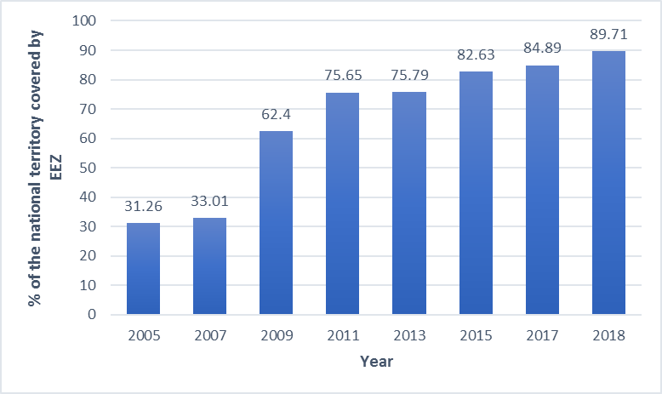

*Source: MMA.*

The EEZ Brazil Consortium, comprised by 15 public institutions (such as ANA, CPRM – Brazilian Geological Service, Embrapa, Ibama and IBGE) counts with installed capacity and accumulated experience that allows cooperation both with state level actions and with federal EEZ actions. The Coordinating Commission of the Ecological-Economic Zoning of the National Territory (CCZEE) functions as the political entity responsible for planning, coordinating, monitoring and evaluating EEZ development activities.

***Figure* 17 *-*** *EEZ initiatives completed in 2018*Uma imagem contendo texto, mapa

Descrição gerada com muito alta confiança

Source: MMA.

*Local Agenda 21*

The Brazilian Agenda 21 represented an important process and planning instrument for sustainable development and social equity. Municipalities and communities organized themselves according to the Local Agenda 21 format, including by establishing the Local Agenda 21 through municipal laws. Actions connected to the Agenda 21 continued even after the global level succession from the Agenda 21 to the Millennium Goals (2000) and followed by the Sustainable Development Goals (2015).

The Local Agenda 21 played the role of participatory planning process for individual territories, for promoting sustainable development. For the Brazilian government, the construction of the Local Agenda 21 contributed to the development of management and planning instruments for sustainable development. Comprised by government and civil society, the Agenda 21 Forum was responsible for the development of Local Sustainable Development Plans, which provide structure for the implementation of local priorities, define responsibilities of governmental sectors and other local society sectors in the implementation, monitoring and revision of these projects and actions (IBGE, 2015).

Results of the 2015 Munic report (IBGE, 2015) indicate a growing engagement in Local Agenda 21 between 2012 and 2015. The percent of Brazilian municipalities initiating the preparation process for this instrument increased from 18.1% (1,010) to 22.0% (1.225), and the increase was observed in all classes of population size and in almost all Large Regions. Of particular notice are the municipalities with over 500,000 inhabitants, with an increase from 57.9% (22) to 75.6% (31), and the North Region, with an increase from 30.3% (136) to 39.6% (178) of municipalities (Figure 18, Indicator A2.2).

**Figure 18 -**Percent of municipalities that initiated the process to develop the Local Agenda 21, by Large Regions and classes of municipal population size - 2012/2015 (Indicator A2.2)

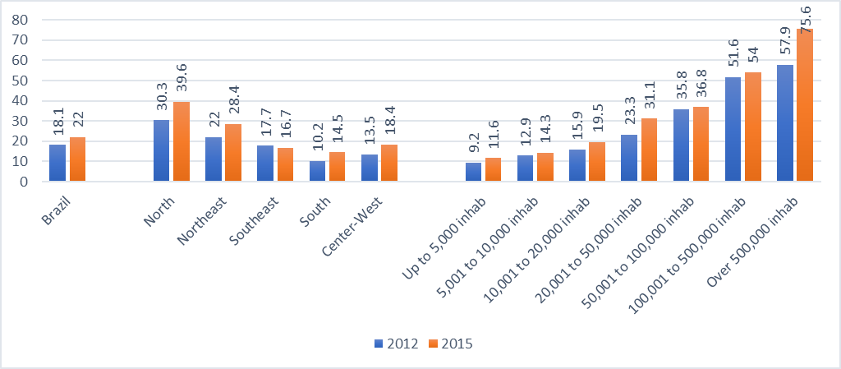Source: IBGE.

The internalization of environmental discussions under the Agenda 21 at the different Brazilian levels of government seems to be reflected in the mobilization for the SDGs, including concerning local powers such as city halls and non-governmental organizations.

The National Confederation of Municipalities – CNM is adopting the SDGs as target, calling attention to the role of municipalities in Agenda 2030. Courses, websites, social networks, workshops, videos and publications such as the “*Guide to Locate the Sustainable Development Goals in Brazilian Municipalities: What municipal managers need to know*” (CONFEDERAÇÃO NACIONAL DE MUNICÍPIOS, 2016)*.* A strong emphasis is noted on practical suggestions for actions necessary to promote the advancement of municipalities/local power in the implementation of the goals, in addition to tools that allow measuring and demonstrating the performance and advances in each municipality. The civil society is also organizing itself to collaborate with the achievement of the SDGs, by participating in representative councils with governmental participation (CIVIL SOCIETY WORKING GROUP FOR SUSTAINABLE DEVELOPMENT AGENDA 2030 [between 2015 and 2018]), or through independent organization (ESTRATÉGIA ODS, 2015).

*Integration of biodiversity and ecosystem services in public policies and business sector actions*

The integration of biodiversity and ecosystem services values into national and local strategies, into national accounting, into planning procedures and reporting systems in the public and private sectors, requires economy to recognize the value of ecosystems and, for that, it is necessary to clearly demonstrate the economic value of biodiversity. The project “Biodiversity Conservation through the Integration of Ecosystem Services into Public Policies and Corporate Action – Regional-Local TEEB Project” played an important role by creating awareness among managers and creating instruments about the value of biodiversity in the production processes and in public management instruments.

The Regional-Local TEEB Project was a partnership among the Brazilian Ministry of the Environment, National Confederation of Industries and the German government represented by the German Technical Cooperation (Deutsche Gesellschaft für Internationale Zusammenarbeit) and was developed under the international initiative The Economics of Ecosystems and Biodiversity – TEEB. The project had the objective of promoting the internalization of biodiversity and ecosystem services values by decision processes at all levels through a structured assessment approach that recognizes the benefits provided by ecosystems and biodiversity in economic terms.

Along its seven years of existence, the Regional-Local TEEB Project sought to integrate ecosystem services into four themes: public policies for planning, territorial and protected areas planning and regularization; public policies on economic incentives for the conservation and sustainable use of biodiversity and ecosystems; corporate management strategies and development of environmental economic accounting. Tools were developed to evaluate ecosystem services for corporations in the Brazilian context and case studies were promoted. The project’s components sought to integrate ecosystem services into public strategies and policies, regional and local development, management of small and medium companies, and support to the development of Environmental Economic Accounting. The 67 publications prepared or supported by the project, as well as other project results, are available at the MMA website[2].

The project supported the internalization of the biodiversity and ecosystem services theme into 14 policies, plans, programs and environmental management instruments in three biomes (Atlantic Forest, Cerrado and Amazon), six of which at the federal level, seven at the state level and one at the municipal level. The project focused on the internalization of the ecosystem services theme by planning instruments (for land use and occupation, territorial planning and regularization, studies, directives and communication support) and by economic incentive instruments (initiatives related to programs on payment for ecosystem services, initiatives on incentives to sustainable products and products from socio-biodiversity, initiatives related to environmental adjustment or compensation mechanisms).

Thus, in short, the project supported awareness and capacity building of key local and national actors, as well as the coordination between these actors and institutions, and the development of methodologies, tools and technical approaches. The project also resulted in a Manual on the Approach to Integrate Ecosystem Services into Development Planning (ISE) and a Summary for decision makers on biodiversity and ecosystems, addressing the challenges and opportunities for Brazil.

The Brazilian corporations showed interest in the new technologies for environmental management and recognized the value of Brazilian natural capital, but still need to find concrete opportunities to integrate this value into their strategic planning. Initiatives to integrate biodiversity into city planning have been recently initiated and promise to generate positive impacts to conservation and life quality at large Brazilian metropolises.

The Regional-Local TEEB Project focused on promoting examples of effective implementation at the local and regional level, with the purpose of providing models for the integration of biodiversity and ecosystem values into development, and of reinforcing the dialogue among public and private actors. Since 2012, the project developed partnerships with decision makers at the regional and local levels, which allowed to build the capacity of key actors (see Target 1) and the joint structuring of pilot projects (MMA, 2018b).

Impacts achieved along project implementation:

1. Promotion of economic instruments and financing mechanisms;
2. Dissemination of key messages on the value of ecosystem services and natural capital;
3. Integration of the focus on ecosystem services into capacity building, planning and decision making, with the publication of 44 case studies;
4. Strengthening land use planning and ecosystem management using information on ecosystem services with the participation of 43 corporations;
5. Incorporation of natural capital into decision making processes in the private sector by approximately 75% of the key actors that participated in capacity building initiatives.

The Sustainability Studies Center (GVces) of the Corporate Administration School of the Getúlio Vargas Foundation (FGV-EAESP) in São Paulo launched in 2013 the corporate initiative Trends in Ecosystem Services (TeSE). In collaboration with the associated corporations, TeSE developed business management tools to value their own vulnerabilities and impacts on natural capital. In 2014, the Regional-Local TEEB Project joined the initiative and provided a technical review of priority ecosystem services and financial support for the application of corporate directives for the assessment of ecosystem services in 23 corporations, published between 2014 and 2018 (MMA, 2018a).

In this context, the Getúlio Vargas Foundation (FGV-EAESP) and the TEEB Project jointly collaborated with Brazilian corporations in the development of “Directives for integrating ecosystem services in decision making processes”. One of the main TeSE concerns was to develop practical methodologies applied to a business context. The initiative adapted the developed directives and tools to the Brazilian context and provided capacity building to associated corporations on the use of DEVESE and its calculation tool. The pilot studies were published with the objective of creating a set of references for the practical use of DEVESE and environmental assessment in the business context. The development and implementation of directives and tools required the creation of partnerships among various interested parties, the design of communication strategies to invite corporations to join the partnership, the identification of gaps in the development of capacity and the preparation of training and the strategic implementation of tools and instruments.

*Environmental Economic Accounting*

Brazil has advanced regarding national environmental accounting. IBGE, the national agency responsible for official statistics, represents the country at the System of Environmental Economic Accounting (SEEA), made available by the United Nations – UN. The SEEA establishes an international standard for environmental economic accounting, integrating economic and physical data and providing a broad and multifaceted vision of the inter-relationships between environment and economics. The country also seeks to integrate the Environmental Economic Accounting into the National Accounting System – SCN, also under IBGE’s responsibility, considering environmental assets. In Brazil, the incorporation of the national water accounting is already established and the conclusion of studies on the Environmental Economic Accounting is expected for 2019 through the TEEB Project, as follows:

* *The Contribution of Environmental Economic Accounting to public policies in Brazil: Water*
* *The Contribution of Environmental Economic Accounting to public policies in Brazil: Energy*
* *The Contribution of Environmental Economic Accounting to public policies in Brazil: Forests.*

In addition to the progress of these studies, there is a possibility to incorporate environmental aspects in the national public accounting with the creation of the Green National Product – (GNP, or PIV in Portuguese), also known as Green GNP. This is an index created to calculate the national ecological heritage, created by Law 13.493/2017, which should establish an environmental economic accounting methodology and system to be officially adopted in Brazil, under IBGE’s responsibility.

**CASE STUDY: TeSe Corporate Cases**

**Valuation of the externality in agriculture crops promoted by natural pollinators of Permanent Preservation Areas (APPs) restored by the Mata Viva Program®**

BASF is a German chemical corporation with business in Brazil at the following states: São Paulo, Paraná, Rio Grande do Sul, Bahia and Pernambuco. Since 2008, BASF has been implementing, with support from Espaço Eco Foundation, the Mata Viva**®** Education and Environmental Conservation Program. One of its lines of action is the support to rural producers for the environmental adjustment of their properties through studies that quantify and technically indicate how to resolve their pending environmental issues through the restoration of Permanent Protection Areas – APP and Legal Reserves – RL. Since the beginning of the program, studies have been carried out for the necessary adjustment of over 30,000 hectares in rural properties to achieve environmental compliance and approximately 710 hectares have been restored through the planting of over 1.1 million seedlings of native species.

To understand the consequences of the restoration activities, an inventory was carried out in 2014 to assess bee biodiversity and abundance in three properties that had their areas restored by the program at least five years ago, located in the municipalities of Bebedouro, Tanabi and Araraquara, all in São Paulo state. This case study seeks to promote the understanding of the importance of ecological restoration for the reestablishment of bee biodiversity through the valuation of the ecosystem service of pollination regulation.

The three restored areas are located in municipalities with low percent cover of native vegetation and presenting long-standing development of technology-dependent agriculture. The study sought to emphasize the importance that ecological restoration can represent to the increase of agricultural productivity in third-party properties – an externality aspect – due to the increase in the number of native bees. Given that the crop grown in the three properties is sugar cane, which does not depend on pollination, three scenarios were considered for the contribution of the increase in the number of bees and consequent increase in agricultural productivity in coffee and orange crops, which are present as large-scale crops in the region.

To define a value for the externality generated by the ecosystem service of pollination, the Marginal Productivity Method – MPM was applied, estimating the economic value associated to the share of third-party production, which varies as a function of the availability of pollinators originating from the restored areas. The valuation was carried out for 2016. This study identified that the investment made by the corporation to restore APP forests in agricultural properties of partner rural producers contributed to generate a positive externality to each of the properties of, respectively, R$ 20,800, R$ 19,500 and R$ 55,900 per year (orange crops); and of R$ 36,600, R$ 32,500 and R$ 98,500 per year (coffee crops). The results of the study support the corporation’s strategy to achieve corporate development with sustainability-oriented management and, consequently, making tangible the result of the effort and dedication applied and encouraging the development of new initiatives[3].

**Evaluation of the impact of reduced water provision on energy generation at a Small Hydroelectric Powerplant – PCH**

The Toctao Group includes in its portfolio private works at different scales and segments, from hydroelectric powerplants to residential buildings. The Group’s activities, particularly those related to energy generation, are strongly connected to ecosystem services, as they directly depend on the provision of water, making it relevant to understand these relationships.

Since 2008, the Toctao Group operates two Small Hydroelectric Powerplants – PCHs on the Palmeiras River in Tocantins. This water course holds a complex of nine cascading hydroelectric ventures of the run-of-river type, where the Toctao facilities are located furthest downstream. The study verified that from 2009 to 2016 a 15% average reduction in energy generation occurred, resulting from the river water flow. Considering that a reduction in generation impacts the venture’s economic viability, the study applied the Marginal Productivity Method – MPM to calculate the impact of the reduced water provision to this business during the 2009-2016 period.

The study’s results indicate that the water deficit resulted in a loss of income of approximately R$ 11 million in the period, accounting only those years presenting insufficient water flow to generate the physical warranty (amount of energy expected within the technical parameters that can be used for commercialization through contracts). Once the dimension of this impact was understood, the study sought to identify which environmental aspects were related to water provision to guide management actions and the reduction of risks to which the venture is exposed. The study sought to understand the dynamics of the environment in which the PCHs are installed, evaluating satellite images and the respective land uses in the period before the construction of the facilities, as well as rainfall data since the beginning of the powerplants’ operation.

The data analysis enabled the observation that the sub-watershed of the Palmeiras River faces pressures in the west from the advance of intensive agriculture with the use of center pivot irrigation. However, it was not possible to determine a dose-response function of the land use change or the intensification of processes in the region as a determining factor for water flow reduction. It was also observed that the advance of agriculture towards the west was barred by topographic conditions, which prevent the use of machinery essential to this type of agricultural practice and that, within the micro-watershed, no significant changes in land use occurred in the period from 2009 to 2016.

This study emphasized that the advance of degradation on the borders of the watershed close to the headwaters of the Palmeiras River is impacting the provision of water for energy generation and for other uses related to the river. Even through it was not possible to determine the dose-response of the land use change impact, the need to mobilize actors and responsible agencies is emphasized to achieve better land and water use management in the region[4].

**CASE STUDIES: Integrating Biodiversity into the Private Sector**

**The contribution of the Votorantim Reserves to the Aichi Targets**

Votorantim is a private corporation that seeks to integrate biodiversity values into development through the implementation of various projects related to the Aichi Targets and to the National Biodiversity Targets.

Target 4: Plant nursery of native Atlantic Forest species (Water Legacy and Greens of the Cerrado Legacy) + Production of native plants of the Atlantic Forest and Cerrado biomes focusing on restoration projects, reforestation and landscaping, including urban afforestation.

Target 5: Monitoring and Surveillance Program of the Water Legacy and Greens of the Cerrado Legacy Private Reserves + Promotes the protection of the area, combatting illegal extraction of fauna and flora from the reserves, illegal deforestation and suppression, illegal land occupation and hunting.

Target 7: At the Greens of the Cerrado Legacy, 4,000 of the 32,000 protected hectares are allocated to the integration of sustainable management, including soy production and livestock raising, and a synanthropic agriculture project.

Target 13: Creation of the Virtual Forest, the largest genetic bank for the Atlantic Forest in the world, containing DNA[5] fragments of 53 Brazilian native species. In addition to securing genetic information, the purpose of the Virtual Forest is to create an equivalent library of plant extracts with the objective of accessing genetic resources for bioprospection, in compliance with Law nº 13.123/2015.

Target 15: The Votorantim Reserves maintain a total of 63,000 hectares of protected areas in the Water Legacy and Greens of the Cerrado Legacy, ensuring the conservation of ecosystem services and carbon stocks. The 32,000-hectare Water Legacy, located in the Atlantic Forest of São Paulo, represents 1.32% of the total remaining native vegetation of this biome in the state; while the Greens of the Cerrado, in the state of Goiás, comprises 32,000 hectares of the remaining Cerrado.

Target 1: Environmental Education Program: The Water Legacy and the Greens of the Cerrado Legacy carry out environmental education programs with the purpose of contributing to a cultural change in favor of the conservation of biomes and of biodiversity. The environmental education programs at the reserves are carried out within their territories. The Water Legacy implements these programs in the Ribeira Valley, mainly in the municipalities of Juquiá, Miracatú and Tapiraí. The Greens of the Cerrado Legacy works at the municipality of Niquelândia, as well as in Uraçu. The programs address conservation awareness, as well as green economy and green infrastructure themes.

Target 3: Positive incentives: Provision of financial and human resources for the development of the Regional Integrated Tourism Plan for the municipalities of Juquiá, Miracatu and Tapiraí (Ribeira Valley). The tourism plan was prepared focusing on the structuring and insertion of the municipalities of Juquiá, Miracatu and Tapiraí in the tourism trade, considering the opportunity for the creation of jobs and entrepreneurship in the region, as these municipalities present high touristic potential given the high degree of Atlantic Forest conservation along the Ribeira Valley, particularly in these municipalities, and the natural attractions of the Atlantic Forest biome.

Target 5: Protection, monitoring and surveillance of the Atlantic Forest and Cerrado reserves – 31,000 hectares of the Water Legacy and 32,000 hectares of the Greens of the Cerrado Legacy – for environmental protection, preventing deforestation, illegal occupation, hunting or any type of fauna and flora extraction from the reserves.

Target 11: Creation, between 2012 and 2015, of a total of 63,000 hectares of private protected areas in two of the most threatened Brazilian biomes: Water Legacy, with 31,000 hectares of Atlantic Forest, and Greens of the Cerrado Legacy, with 32,000 hectares, both registered in perpetuity. The creation of these Private Reserves of the Natural Heritage – RPPNs is based on an innovative business model, which seeks to promote the generation of shared value aligning territorial development and income generation for the corporation, and reinvestment in forest conservation. The strategic management plan of Greens of the Cerrado Legacy also seeks to harmonize the development of green economy activities with traditional economy.

Target 12: Focusing on the protection of fauna and flora, the Water Legacy promotes the conservation and management (Environmental Study and Ecotourism activities) according to its Strategic Management Plan, which is enhanced based on the results of scientific research that generate information on ecology through the following programs: Monitoring of Tapirs; Monitoring of medium- and large-size Neotropical Carnivores; Monitoring of Wooly Spider Monkeys; Monitoring of Lepidoptera (Butterflies and Moths); Inventory and Retrieval of Orchids; Inventory of Herpetofauna (amphibians, anurans and reptiles) and scientific dissemination; Inventory of small mammals at the Water Legacy/Preparation of a study of zoonotic agents and their vectors in wild and domestic animals.

Target 14: Water Springs Recuperation Program – Greens of the Cerrado Legacy at the municipality of Niquelândia.

Target 18: Recognition of the Cabocla Traditional Community of Ribeirão da Anta: The objectives and lines of action for recognizing the Community of Ribeirão da Anta focus on social mobilization and organization, recognition of the natural heritage, infrastructure, institutional strengthening, environmental education and sustainable tourism. Since 2013, the Water Legacy has supported the community towards the public recognition of their traditional community characteristics, resulting in the document/recognition by the Tapiraí municipality. Between 2013 and 2016, a historical inventory of the community resulted in the publication of the book Ribeirão da Anta, featuring the historical retrieval of a cabocla community of Tapiraí/SP. The book rights were granted to the community.

Prepared by: National Confederation of Industries – CNI

IBA: Planted forests and biodiversity

The planted forests sector has been working on national and international initiatives to demonstrate and value biodiversity and the role of industry in its conservation. Among the 20 Aichi Biodiversity targets, eleven (1, 3, 4, 5, 7, 11, 12, 13, 14, 15, 16) are strongly related to the planted forests sector. It is relevant to note that the sector allocates approximately 6 million hectares of natural vegetation to conservation in Permanent Preservation Areas – APPs, Legal Reserve – RL areas and Private Reserves of the Natural Heritage – RPPNs. For each hectare planted for commercial purposes, 0.7 hectare is allotted to conservation. This conserved area is responsible for stocking approximately 2.48 billion tons of CO2eq.

In addition to the preserved area, the sector also invests in the restoration of degraded ecosystems. In 2016, considering exclusively the corporations associated to Ibá, restoration processes were initiated in 50,000 hectares, mainly focusing biodiversity protection at the Atlantic Forest and Cerrado biomes. An analysis of the studies carried out at the action sites of forest-base corporations pointed out that, among threatened species in Brazil, 38% of the mammals and 41% of the birds were recorded at the areas maintained by these corporations (see pictures below). In this context, the Brazilian planted forests sector combines efforts to build a country guided by the values of a truly sustainable low-carbon economy, considering productive management and the adoption of good land use practices.

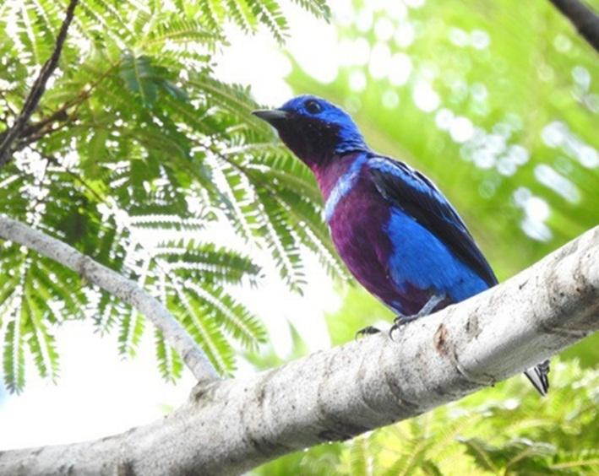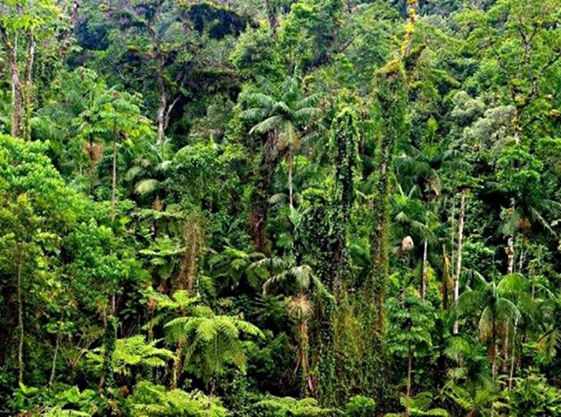Prepared by: CNI

Credits: Daniel de Granville and Priscilla Sales

1. Results of the 2nd updating of priority areas available at: <http://www.mma.gov.br/informma/item/10724-resultados-da-2%C2%B0-atualiza%C3%A7%C3%A3o-das-%C3%A1reas-priorit%C3%A1rias.html>
2. The publications can be found at: <http://www.mma.gov.br/images/publicacoes/biodiversidade/economiadosecossistemas/ListaPublica%C3%A7%C3%B5es/TEEB_lista_publicac%CC%A7o%CC%83es_Final_site.pdf>
3. Additional information available at: http://mediadrawer.gvces.com.br/tese-casos/original/02-cases_ciclo2017_tese_port_basf2_2.pdf
4. Additional information available at: <http://mediadrawer.gvces.com.br/tese-casos/original/08-cases_ciclo2017_tese_port_toctao.pdf>
5. Deoxyribonucleic acid – DNA.