**Case Study 2.8 Protection of Germplasm Resources of *Astragalus membranaceus* var. *mongholicus* (Bge.) Hsiaoin**

*Astragalus membranaceus* var. *mongholicus* (Bge.) Hsiao is a well-recognized high-quality authentic astragalus in traditional Chinese medicine. The germplasm resources of *Astragalus membranaceus* var. *mongholicus* are one of the most important germplasm resources in the world. This astragalus has been in a wild and semi-wild state for a long time. It has been naturally selected and evolved over hundreds of years, and natural hybridization and variation have formed a unique population. In recent years, with the expansion of artificial cultivation area, there are more demands in the market for seeds of astragalus. The price of astragalus seeds is higher than that of other production areas. Some merchants have transported seeds from Gansu and other places for sale at the local market, causing the gradual loss of the original seed source of *Astragalus membranaceus* var. *mongholicus* and hybridization and downgrading of germplasm resources.

In order to effectively protect the germplasm resources of *Astragalus membranaceus* var. *mongholicus*, since 2016, Shanxi Beiyue Shenqi Biotechnology Co., Ltd. has invested more than 14 million yuan, and the local government and governments of higher levels have invested 1.6 million yuan. A slope land of a total of 240 hectares for the astragalus, which has been uninhabited for over 20 years close to the Qianshao Village of Peicun Town and has been rented for growing the astragalus. A rough road of more than 5 kilometers was built for transportation and 8 rooms built for management personnel. More than 66.7 hectares of slopes with good isolation conditions and suitable for wild astragalus growth (historically never artificially sowed) were fenced for *in situ* conservation of germplasm resources of wild astragalus. Excellent seed plants were selected and labelled, and seeds collected. Large perennial weeds and shrubs were manually removed to let the astragalus seeds fall naturally, naturally multiply, and grow in the wild environment. The collected excellent germplasm resources were studied and utilized, and varieties that are suitable for local cultivation, with high quality, high yield and strong resistance, were cultivated. Through the continuous conservation of germplasm resources, the seedlings and varieties of the astragalus seedlings are moving towards authenticity, high quality, high yield and high efficiency.

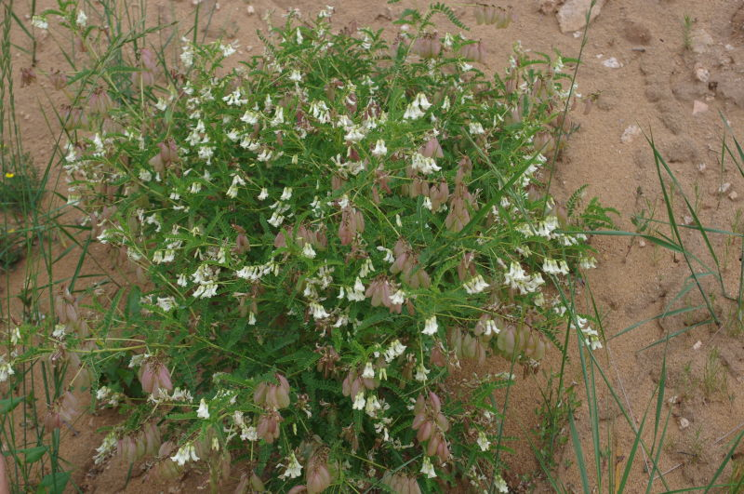 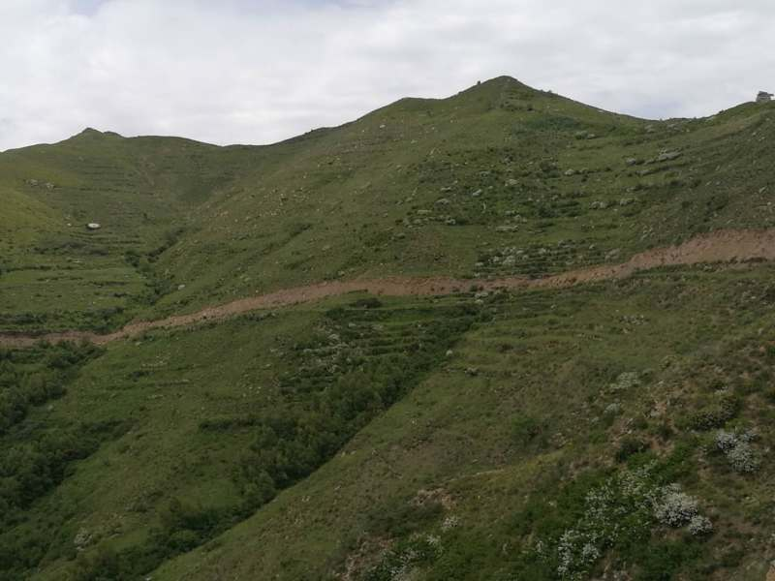 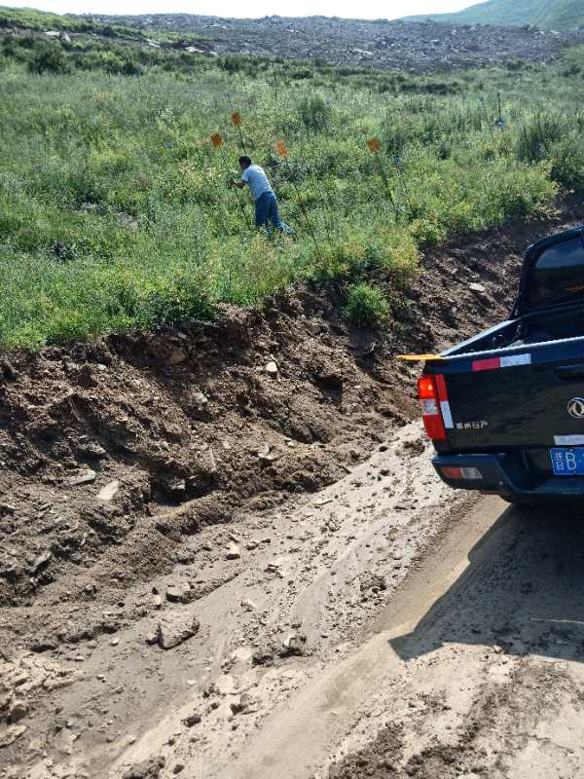

***Astragalus membranaceus* Habitats of germplasm Labelling for key**

**var. *mongholicus* protection base individual plants**