**Case Study 2.7 Survey and Protection of *Atractylodes lancea* (Thunb.) DC. Germplasm Resources**

*Atractylodes lancea* (Thunb.) DC. is a perennial plant of Compositae. Its rhizome has the effects of dispersing phlegm and cold, drying out dampness, tonifying spleen, and improving eyesight. It is a commonly used traditional Chinese medicine. Maoshan mountain of Jiangsu Province is famous for producing genuine medicine. In recent years, due to the impacts of various human factors and its biological characteristics, the population's self-recovery ability is poor, and its distribution area and population number show a tendency of obvious decline. It has been listed as one of the four endangered medicinal plants in Jiangsu Province. In recent years, Nanjing University of Chinese Medicine in collaboration with Zhenjiang City Drug Inspection Institute, Jiangsu Maoshan Genuine Chinese Herbal Medicine Planting Co., Ltd. and other Chinese herbal medicine production bases, carried out investigation, gene bank construction, transcriptomics, rapid propagation and wild breeding of the endangered medicinal plant *Atractylodes lancea*. The research work leads to better knowledge of the distribution and resource reserves of *Atractylodes lancea* in Jiangsu Province, and a comprehensive understanding of the biological characteristics of *Atractylodes lancea* as well as the causes of endangerment occurred. Building on all this, the gene bank of excellent germplasm resources of *Atractylodes lancea* was established. The collected roots and seeds of *Atractylodes lancea* were preserved in the gene bank of Nanjing University of Chinese Medicine, realizing the *ex-situ*, long-term preservation in different places. The transcriptomic platform was established for the stems and leaves of the excellent germplasm of *Atractylodes lancea*. Relevant genes were screened to acquire active components of synthetic organisms. The research on tissue culture of *Atractylodes lancea* was carried out, and the rapid propagation system was established. The suitable breeding areas and tending conditions of *Atractylodes lancea* were determined, and the number of wild populations and the number of individuals in the population were increased. The research results provide technical support for the long-term preservation of germplasm resources of *Atractylodes lancea*, lay the foundation for the research and utilization of functional genes, guide the research on quality seed breeding, and provide scientific basis for bioengineering applications to promote the preservation and sustainable use of this excellent germplasm resources.

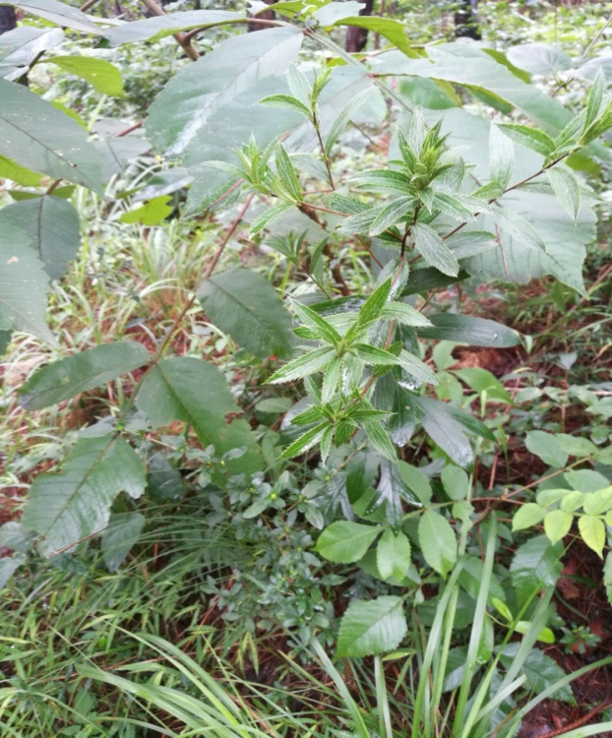 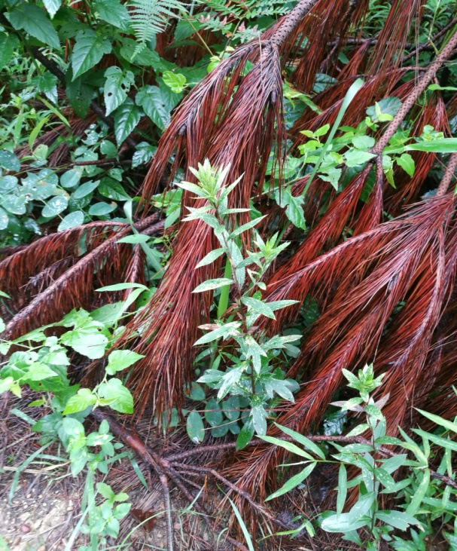

**Survey of *Atractylodes lancea* germplasm resources**