**Case Study 2.5 Native Plant Protection Full-coverage Plan Enhances Plant Diversity Conservation**

In 2013, the Chinese Academy of Sciences took the lead in establishing the China Botanical Garden Alliance and launched the Native Plant Protection Full-Coverage Plan to protect rare and endangered native plants. Through a series of steps such as native plant cataloging, expert evaluation, and field visits, the field survival status of native plants in each region is determined, and various tools in the Conservation Biology Toolbox are applied to protect the species with high threat levels in a targeted manner to ensure they are not at risk of extinction.

(1) Assessment of the survival status of native plants in the field. At present, Xishuangbanna Tropical Botanical Garden, Wuhan Botanical Garden, South China Botanical Garden, Kunming Botanical Garden, Beijing Botanical Garden (Institute of Botany), Guilin Botanical Garden, Nanjing Zhongshan Botanical Garden, Turpan Desert Botanical Garden, Shenyang Arboretum, Lushan Botanical Garden, Qinling National Botanical Garden, Chongqing Nanshan Botanical Garden, Fuzhou Botanical Garden and Hunan Forest Botanical Garden participated as leading institutions in the full coverage protection plan. At present, with reference to the IUCN Red List evaluation criteria, assessments of 64,879 plant species/sub-species in 14 regions have been completed, and 210 plant experts/times have participated in the assessments. The assessment results showed that 56 species/time are regionally extincted, 1257 species/time are critically endangered and 2,234 species/time are endangered. The number of threatened species accounted for 11.72% of the total number of species assessed.

**Status of Threatened Native Plants in Pilot Regions**

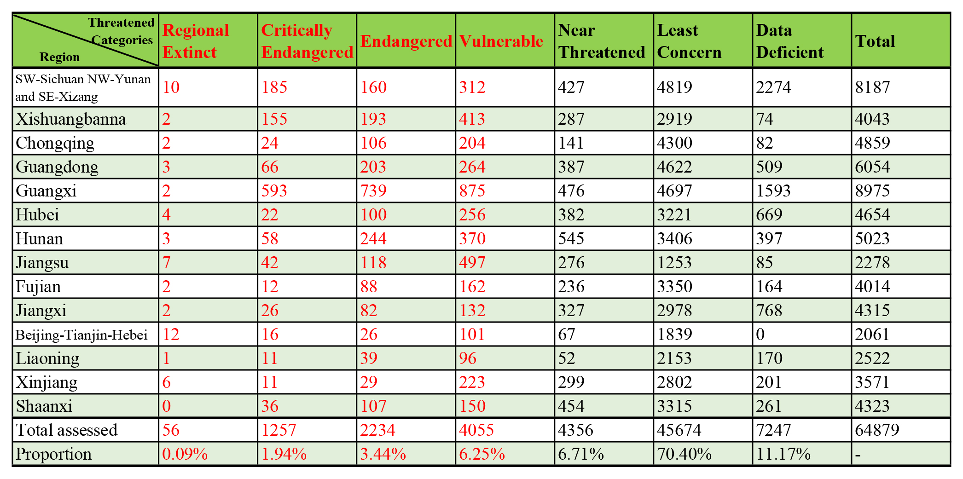

(2) Field trips. After having assessed the initial situation of threats to native plants in the area, the experts organized survey teams and identified field study routes to conduct field studies on seasonal basis targeting those species that are extinct, critically endangered, endangered, vulnerable and lacking in data, and to verify the field survival status of these plants and adjust their threat level based on the survey results. At present, field surveys have been organized hundreds of times, and 501 extremely endangered species, 773 endangered species, and 1,299 vulnerable species have been surveyed. A large number of native plant images, habitats and location information have been recorded, which has laid a good foundation for taking protective measures in the next phase.

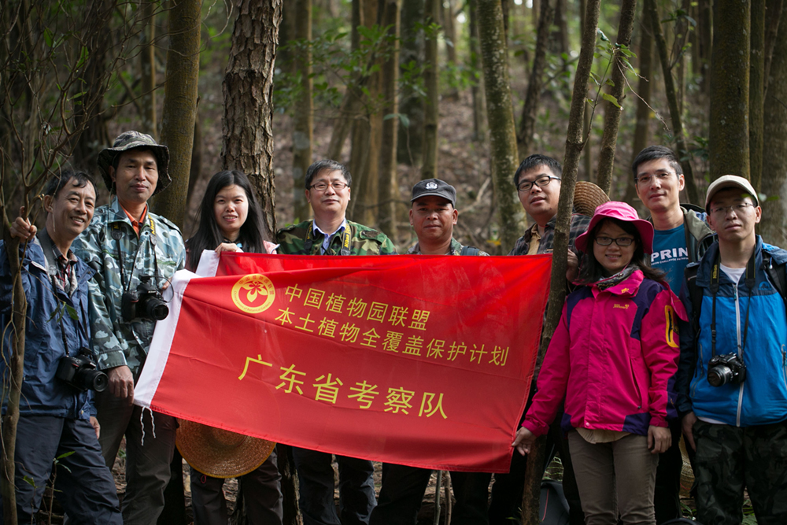 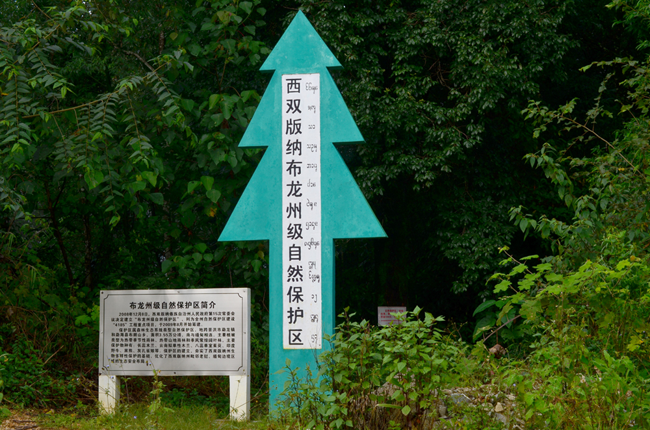

**Field survey of native plants Establishment of (small) protected areas**

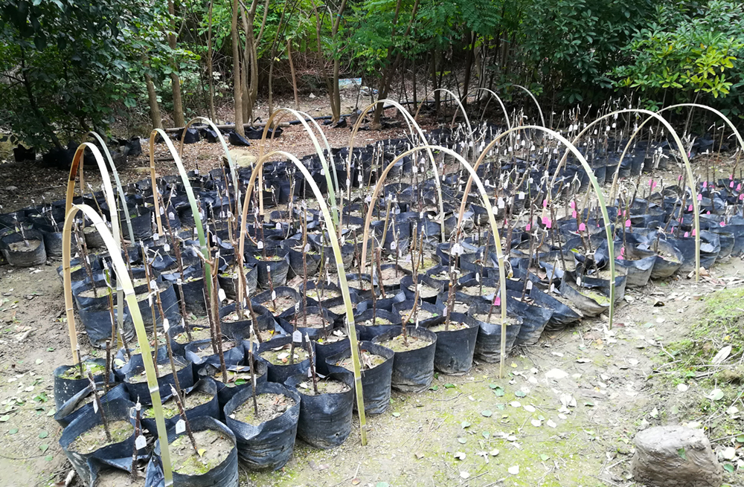 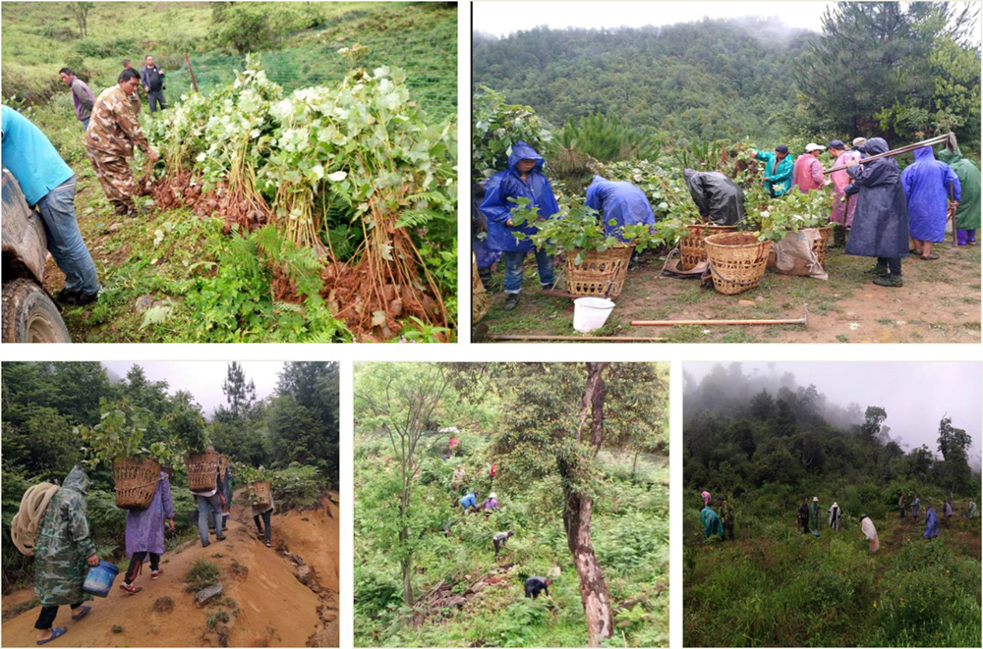

***Ex-situ* conservation Reintroduction to nature**

(3) Taking protective measures. For species that are seriously threatened in the wild, they are protected from extinction by adopting measures such as *ex-situ* conservation and *in-situ* conservation. Since the launch of the project, two nature reserves in Xishuangbanna Bulong and Yiwu have been established. And the local forestry bureau has also established small protected areas for conservation of endangered plants such as *Pachylarnax sinica, Acer yangbiense,* and *Sinojackia dolichocarpa*. *Ex-situ* conservation measures have been taken to protect 278 critically endangered plant species, 489 endangered plant species and 773 vulnerable plant species in botanical gardens. Dozens of endangered plant species such as *Paphiopedilum spicerianum, Pelatantheria rivesii, Acer yangbiense and Bretschneidera sinensis* have been reintroduced to the wild.