**Case Study 2.3 Baerluke Mountain Successfully Promoted to National-Level Nature Reserve**

Baerluke Nature Reserve is located at the transition area from Taiga forest community in Ertai Mountain to desert community in Tianshan Mountain. It has primitive habitats and rich biodiversity. It also has the world’s largest area of wild almond trees (1600 hectares) which have important values of scientific research and conservation.

In connection with the census on Chinese medicinal resources, with the strong support of Xinjiang University, Xinjiang Normal University, Xinjiang Medical University, Shihezi University, Xinjiang Institute of Chinese Medicine and Xinjiang Institute of Ecology and Geography under the Chinese Academy of Sciences, a more detailed survey was undertaken of wild medicinal plant resources in Baerluke Mountain Nature Reserve.

The nature reserve is a gene bank of plant resources in Tacheng region and a habitat for many wild animals as well as an ecological security barrier for northwest China. Most of the nature reserve keeps their original landscapes and has rich forest ecosystem diversity as well as species abundance. The nationally protected wild animals include gold carving, the Siberian ibex, great bustard and snow leopard. As a result of the census, the species and distribution of wild herbal plants within the nature reserve is known and the quantity of reserves of some key herbal plants was calculated and obtained. Information concerning civil application and practice of some herbal plants was also obtained. All this provided a scientific basis for the establishment of herbal plant germplasm and gene banks and the conservation, development and use of herbal plants of this region.

On 19 May 2015, this nature reserve was officially promoted to the national-level nature reserve.

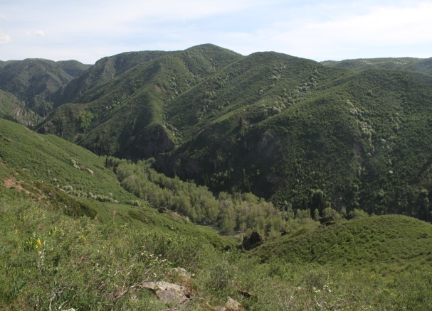 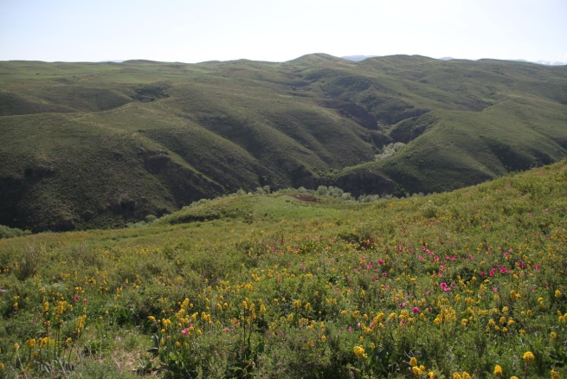

**Part of vegetation in Baerluke Mountain**