**Case Study 2.15 The Man and the Biosphere Program for Biodiversity Conservation**

In order to enhance harmony between man and nature and address the increasingly severe global ecological and sustainable development crisis, UNESCO launched the Man and the Biosphere Programme (MAB) in 1971. With the support of CAS and other relevant departments, the China National Committee for Man and the Biosphere was established in 1978. Since then, China MAB and its secretariat have actively fulfilled their duties and promoted biodiversity conservation.

(1) The MAB Reserve is a site for biodiversity conservation

As of 2018, China has established 34 MAB reserves. The MAB Reserve has three functions: biodiversity conservation, research and education, and promotion of sustainable development. After the Seville Programme under the UNESCO MAB Programme was adopted in 1995, the MAB Reserve was positioned as a site for practicing biodiversity conservation and sustainable development.

After 2013, the China National Committee has adjusted the application and assessment strategy for MAB Reserve, shifting from quantity increase to quality improvement. In connection with China's priority areas for biodiversity conservation, biodiversity-rich areas suitable for practicing sustainable ​​development are guided to apply for MAB Reserve. At the same time, the National Committee strengthened the assessment process and developed a rigorous evaluation plan. For issues identified in the evaluation of 18 MAB Reserves, relevant sites were urged to address these issues.

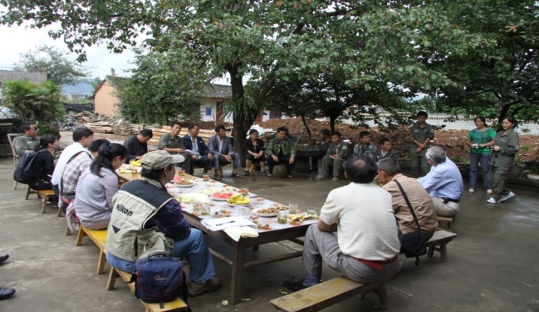

(2) Carrying out training, education and communication

The National Committee established the China MAB Reserve Network in 1995. By 2018, 177 reserves have joined. The network holds annual meetings and trainings for the China MAB Reserve. Since 2015, a systematic training system has been established, and special training workshops on animal and plant monitoring and public science popularization are carried out on a regular basis every year.

(3) Actively communicating the achievements of biodiversity conservation

In 1994, the National Committee established the popular science magazine- Man and the Biosphere, which present the cases and experience of biodiversity conservation at home and abroad, such as those from the implementation of the MAB Program and biodiversity conservation

in China, and special editions on biodiversity conservation in Southeast Asia.

图片1

In 2017, the Committee signed a strategic cooperation agreement with Xinhuanet to open a special channel for “Man and the Biosphere” to promote the MAB Program and biodiversity conservation.

(4) Cultivating talents for biodiversity conservation

In addition to training for all Chinese MAB Reserves, the National Committee has also used the MAB Reserve Network and the East Asian MAB Reserve Network to obtain international training and professional training opportunities for the reserves in China. It has organized 7 East Asian MAB Reserve training activities. In 2018, MAB Reserves in China such as Fanjingshan Reserve and Snake Island Reserve were selected to participate in the specialized training on biodiversity education and island-type protected areas organized by other regions.

Since 2016, the Youth Science Award and the Green Guardian Award have been set up to encourage young professionals in reserves and those who have been directly involved in the management of reserves for a long time. In 2018, in celebrating the 40th anniversary of the establishment of the China National Committee on MAB and the 45th anniversary of China's joining the Man and the Biosphere Program, the Outstanding Contribution Award was presented.

|  |  |
| --- | --- |
| 配图7：中国生物圈保护区生物多样性监测培训主要针对生物圈保护区科研监测人员，提高监测人员信息收集处理能力。 | E:\20180727桌面\中国MAB40年介绍图片\配图\CBRN网络\奖励\配图7：颁奖现场.jpg |