**Case Study 2.14 Science and Technology Support National Biosecurity and Protect China's Biodiversity**

China's import and export trade is very active, and its border lines are thousands of kilometers long, so the animal and plant quarantine at border ports is arduous and the national biosecurity is seriously challenged. Moreover, the inspection and quarantine objects have a wide variety of species and diverse forms, and it is often difficult for quarantine staff to quickly and accurately identify them. The Chinese Academy of Sciences in close and long-standing collaboration with the State General Administration of Quality Supervision, Inspection and Quarantine and port administrations, provides support for national biosecurity through species identification, technology research and development for risk assessment and prevention and control, providing technical training, establishing service platforms, and science popularization.

(1) Species identification. This is done through cooperating with relevant inspection and quarantine institutions nationwide, organizing experts to provide identification reports and techniques for organisms from different countries intercepted by cargo, travel, postal inspections, and collecting invasive species and specimens and information from quarantined species to enrich the IAS database. This is also done through applying new technologies such as DNA barcoding, building a rapid identification system for common quarantine objects and invasive species, determining technical processes and building a standard sequence library to support the rapid species identification. According to the accurate identification results, items with dangerous invasive organisms intercepted will be properly treated to protect China's biosafety.

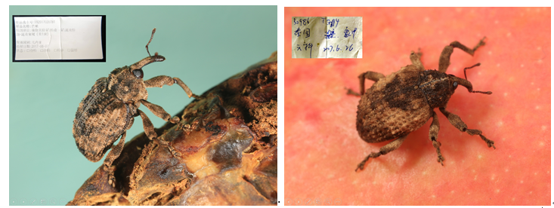

**Supporting identification of pests intercepted. Mango seed weevil (left), fruit weevil (right)**

|  |  |  |
| --- | --- | --- |
|  |  |  |

**Identifying intercepted animal specimens in postal mails in Beijing**

(2) Technology research and development for risk assessment, prevention and control. Based on data such as the existing species distribution areas, models are created to assess the potential distribution areas and economic losses of IAS in China, predict risks of invasion of malignant alien species (such as American bullfrogs and red-eared tortoises) and those species intercepted by ports in China and around the world, and provide risk assessment reports of newly intercepted harmful organisms. Effective technical support is provided for preventing and controlling important IAS to ensure national biosecurity, through research and development of effective prevention and control techniques for trapping and killing important IAS such as red turpentine bark beetle and pine wood nematode, as well as some specialized products such as attractants, synergists, repellents and quantitative slow release devices.

(3) Technical training. According to actual needs, professional teams from CAS provide basic knowledge and skills training for related personnel of the inspection and quarantine administration, as well as internship and exchange opportunities at CAS identification platforms, which helps improve the professional quality and skills of the quarantine personnel.

|  |  |  |
| --- | --- | --- |
| D:\2017 文件\201701 科研资料\01 在研项目\2016-2017 乔格侠口岸检疫项目\20170907 张润志成果\北京首都机场检疫局 20170607 ZRZ_482501 姜春燕拍摄.jpg | D:\2017 文件\201701 科研资料\01 在研项目\2016-2017 乔格侠口岸检疫项目\20170907 张润志成果\北京首都机场检疫局 20170607 ZRZ_480801 姜春燕拍摄.jpg | D:\2017 文件\201701 科研资料\01 在研项目\2016-2017 乔格侠口岸检疫项目\20170907 张润志成果\20170711-ZRZ_562801-机场局访问中科院动物所-姜春燕拍.jpg |

**Technical training for quarantine personnel in Beijing Capital Airport**

(4) Service platform construction. The Border Gate Biosafety Rapid Response Platform is established to provide rapid and accurate species identification, specimen collection and production, information search for quarantined objects and biological risk analysis of intercepted organisms.

(5) Science popularization and communication. The National Biosafety Exhibition Hall was established in the National Zoological Museum to publicize the laws and regulations related to national biosafety, the overall situation of interception and related cases, so that the audience can fully recognize the threats posed by invasive alien species. Since its launch, the exhibition hall has received more than 300,000 visitors as an educational base for national biosafety.

|  |  |
| --- | --- |
|  |  |
|  |  |

**National Biosafety Exhibition Hall**