**Case Study 2.13 Land Remediation Promoting Biodiversity Conservation**

In accordance with the relevant requirements of the Chinese government on the construction of ecological civilization, the Ministry of Land Resources actively promotes the “three-in-one” protection of the quantity and quality of farmlands and strengthens biodiversity conservation in land remediation. In the planning and design of the land remediation project of Jianshan Village, Jinjing Town, Changsha County, Hunan Province, the biodiversity survey was carried out. The project implemented ecological conservation measures such as the construction of ecological ditches, ecological field roads, farmland waterlogging purification systems, ecological berms and corridors, ecological pools and habitats, with due consideration given to the living habits and activity areas of different species. Land use structure is optimized to expand to some extent the living space of biological populations, maintain the biodiversity of the project area, and maintain the balance of the local ecosystems. The farmland with high ecological standards was built.

(1) Construction of ecological ditches. The traditional gully lining methodis were changed to ensure the species migration channel and solve the problems of the ditches causing biological isolation, cutting off the biological chain and affecting the biodiversity. The ditch is ecologically lined, which provides a habitat for aquatic animals and is beneficial to the growth of various aquatic animals and plants.

(2) Construction of ecological field roads. The roads in the project area are made of mudstone pavement, and the pavement is grouted and compacted to provide habitats and corridors for animals and plants living in different ecological landscape patches, which is conducive to the protection and improvement of the ecological environment.

(3) Construction of farmland waterlogging purification system. Two ecological purification systems will be built in the project area. The farmland waterlogging will be collected and discharged to the ecological purification pond. After being purified in the purification pond, it will be discharged into the Jinjing River to achieve the effect of wastewater recycling and self-purification, effectively protecting the river water quality and fresh water resources.

(4) Construction of ecological slopes, corridors and habitats. The project has built ecological slopes, corridors and habitats, giving a living space for aquatic animals and plants, allowing animals falling into the water to climb, escape and migrate. A tea garden around the farmland is reserved as a habitat to meet the needs of the biological populations for their survival and reproduction.

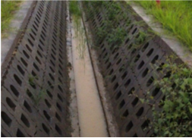 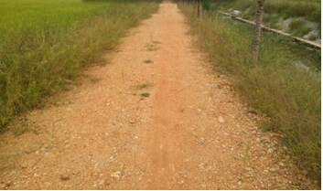

**Ecological ditches Mudstone pavement**

|  |  |  |
| --- | --- | --- |
| QQ图片20140826100207 | 合兴溪施工中-11 | IMG_20140925_085820 |

**Ecological purification system Ecological slope Biological corridor**