**Case Study 2.11 Kezuohou Banner of Inner Mongolia Implements Eco-Poverty Alleviation Strategy for Win-Win for Ecological Conservation and Poverty Alleviation**

Located in the hinterland of Horqin Desert, Tongliao City, Inner Mongolia Autonomous Region, Kezuohou Banner is one of the most seriously desertified and ecologically extremely fragile banners in China. Based on the local reality, Kezuohou Banner promotes the coordination between ecological conservation and poverty alleviation and mutual support among sustainable development and poverty reduction in the ecologically fragile and economically poor region.

The first is to improve the ecological environment and help the local people increase their income. In the implementation of comprehensive desertification control projects, in recent years, the comprehensive treatment of the Horqin Desert has been completed by 273,333 hectares, and the forestry land of the whole Banner has reached 393,333 hectares. The forest coverage rate has exceeded 21%, an increase of 10 percentage points over 2002. The desertification and land degradation in the whole Banner was effectively curbed, forest and grass vegetation recovered rapidly, and the ecological environment improved significantly. The economic benefits from conservation activities are also remarkable. Since 2014, by attracting farmers and herdsmen to participate in comprehensive desertification control, village greening, road greening, high-efficiency water conservation and other projects, the income of local farmers and herdsmen has increased by 51.36 million yuan, of which the poor farmers and herdsmen increased their income by 4.45 million yuan.

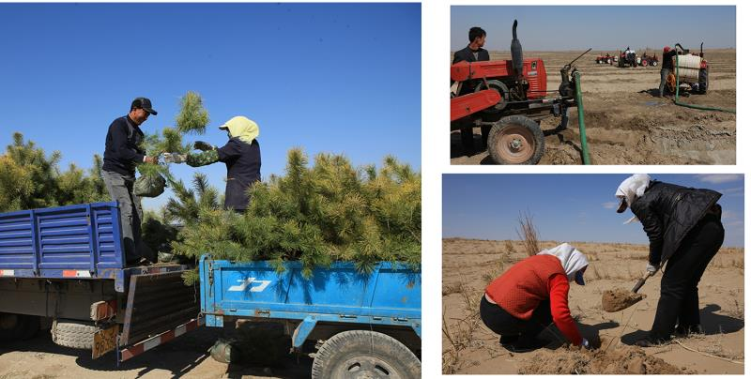

The second is to develop eco-industries to boost the local people’s income. The closure and banned grazing of desertified grasslands were reinforced, with grazing in key areas banned throughout the year. Targeted measures were taken to restore the grassland’s ecological conditions, such as replanting the *Pinus sylvestris* var *mongolica* seedlings and the annual maple (*Acer pictum* subsp. *mono*) in the sparse forest zones, zones difficult for natural regeneration and the large clear areas between forests of the closed areas. While making great efforts to conserve the ecology, the Banner rationally planned the development of related industries by promoting grass plantation and livestock farming. Damages to natural grasslands were avoided while farming yellow cattle. Meanwhile tourism products with ecological and ethnic characteristics were developed. In 2017, 1.4 million tourists have been attracted and a comprehensive tourism income of 1.2 billion yuan was created. The forest fruit industry was developed, the Mongolian and Chinese medicinal herb plantation promoted, and the cultivation of seedling and flower industry fostered. The photovoltaic industry was also developed. All this was intended to transform ecological benefits into economic benefits and people's livelihood benefits.

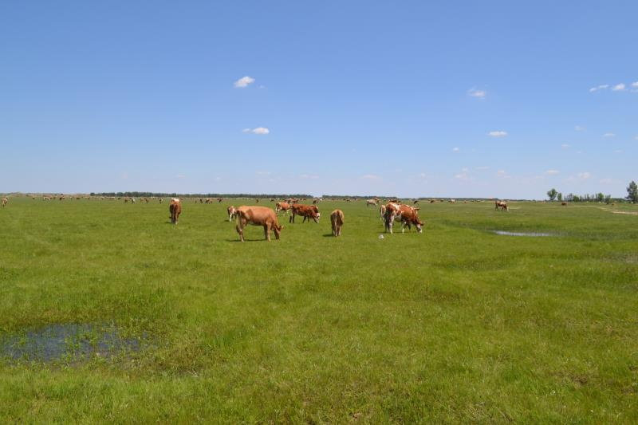

The third is to implement the national ecological policy and ensure the local people’s income increase. The Chinese government has adopted ecological poverty alleviation as an important measure to address the problem of absolute poverty. Kezuohou Banner implements the central government policy accordingly. When hiring the foresters, priority was given to the poor people. A total of 310 ecological forest guards were employed, all of whom were poor people registered. According to the principle of “who protects and who benefits,” each person is paid an annual salary of 10,000 yuan. Meanwhile supervision and verification are undertaken to ensure that the poor protect the ecological environment. From 2014 to 2017, ecological subsidies totaling 50.457 million yuan were distributed, including 92.16 million yuan for subsidies for returning farmlands to forests, 55.76 million yuan for subsidies for public benefits forests, and 356.65 million yuan for grassland awards and compensation. Poor households were guided to use these awards and compensation funds to develop ecological industries, further consolidating and deepening the results of ecological conservation.

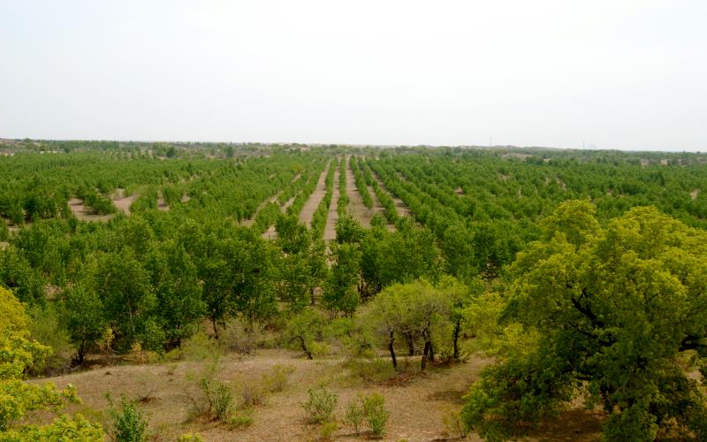

Through various efforts, the local ecological environment has been significantly improved, and the capacity of income generation through ecological conservation has increased significantly. At present, the vegetation coverage rate in the ecological conservation area of ​​the Banner has increased from less than 5% to over 70%. The forest resources of the Banner increased year by year, with the forest land area having increased to 3.4 million hectares, the standing timber stock reached 4.7 million m3 and the forest coverage rate exceeded 21%. Biodiversity was effectively protected. The ecological conservation directly promoted the increase of income of the poor, helped the improvement of the local agricultural production conditions, broadened the channels for the poor to increase income, as well as enhanced local sustainable development and the local people’s livelihood and well-being.