**Case Study 2.1 Assessment of China’s Red List-Macrofungi**

Macrofungi are indispensable degrading agents in ecosystems and provide support for plant growth and survival. They play an irreplaceable role in the material cycle and energy flow in the earth’s biosphere. Meanwhile many edible fungi are closely related to human life and production and therefore have significant social and economic values. China is one of the countries in the world with highest threats to biodiversity. Threats such as overexploitation of natural resources, environmental pollution, climate change, habitat loss and fragmentation have not only caused the decline of some animal and plant species, but also threatened the diversity of macrofungi. However, the status and endangerment level of macrofungi in China is not fully known, thus leading to lack of scientific basis, focus and comprehensiveness in conservation. Therefore, it is important to comprehensively assess the endangerment status of macrofungi and develop a red list in this regard and based on that, develop a conservation strategy with targeted actions. This is important for strengthening biodiversity conservation and promoting the implementation of Healthy China Strategy. To this end, the Ministry of Environmental Protection, together with the Chinese Academy of Sciences, initiated in 2016 the development of China’s Biodiversity Red List- Macrofungi Volume.

The assessment was based on the database for China’s known fungi and relevant literature and documents collected. Through large-scale, rapid screening and initial classification, a comprehensive assessment was undertaken targeting species that require special attention and on the basis of levels and standards for Species Red List developed by IUCN. This assessment made proper adjustments of the IUCN’s assessment standards taking into consideration the differences in biological traits between macrofungi and animals and plants. Estimates or determination of population dynamics and changes in the number of mature individuals were undertaken on the basis of tangible points of distribution and the number of individuals. The data within a certain period of time was used instead of generation length to calculate changes in the population, and “possible extinction” was adopted as one of the endangerment levels for assessment.

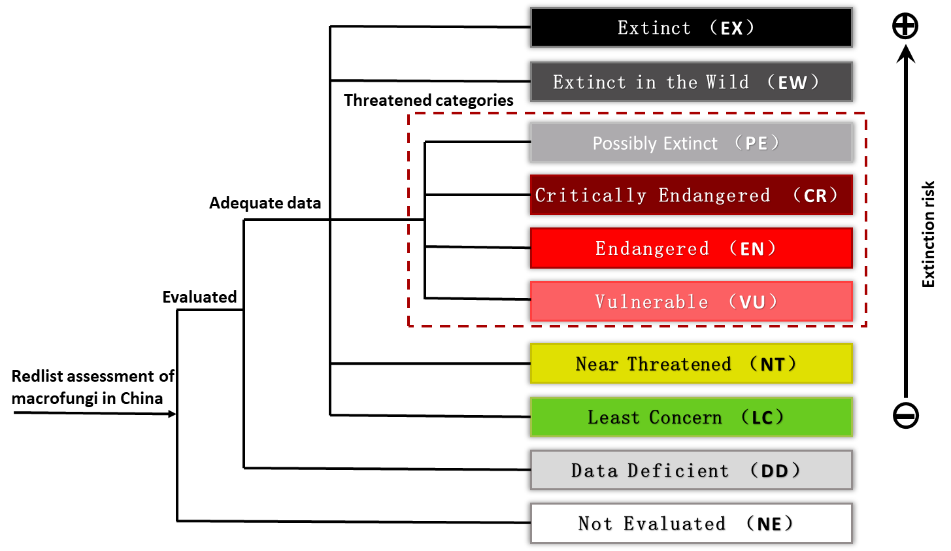

**Classification System for Assessment of China's Red List-Macrofungi Volume**

The assessment brought together more than 140 experts from over 20 institutions across China and covered a total of 9,302 species of ascomycetes, basidiomycetes and lichenized fungi known in China, including 870 species of ascomycetes, 6,268 species of basidiomycetes, and 2,164 species of lichenized fungi. The red list of macrofungi is the largest so far both in China and around the world. It involves an assessment of the largest number of species, the widest range of taxa, the widest spatial coverage, and the largest number of participants. The results showed that there were 97 macrofungi threatened in China, including 24 species of ascomycetes, 45 species of basidiomycetes and 28 species of lichens, accounting for 1.04% of the total number of macrofungi species assessed. There are 57 species of threatened endemic macrofungi in China, accounting for 4.20% of the total number of species of endemic macrofungi in China. *Hemiglossum yunnanense* has not been rediscovered in the past 130 years and is suspected of extinction. The number of macrofungi that require attention and protection is 6,538, accounting for 70.29% of the total number of species assessed.

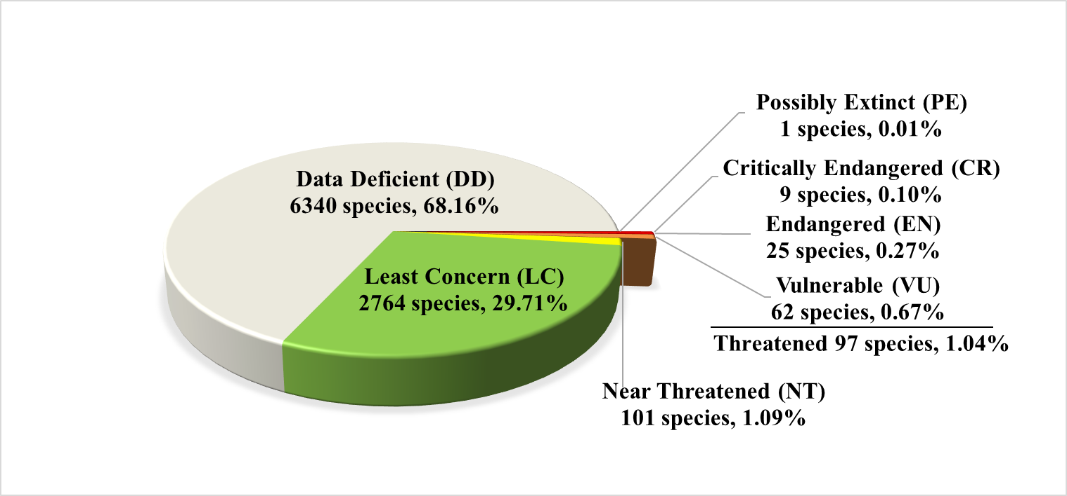

**Threat level and percentage for China's Red List-Macrofungi**

This assessment identified main threats to macrofungi in China. It found that excessive harvesting and improper ways of harvesting are the main threats to edible macrofungi. Environmental pollution and habitat degradation are the main threats to lichen. In addition, habitat loss caused by global warming, land use and deforestation is also an important factor to affect the existence of macrofungi.

This red list assessment of macrofungi has long-standing impacts on the conservation and management of macrofungi diversity. This assessment result provides a scientific basis for the development of relevant policies and programmes by relevant central government departments and local governments for the conservation and sustainable use of macrofungi. This is also a specific action taken by China to implement the Convention on Biological Diversity.