Target 1
By 2020, at the latest, people are aware of the values of biodiversity and the steps they can take to conserve and use it sustainably.
- Background
Increasing public awareness and public participation capacities, and changing behavior and awareness of individuals, organizations and governments are crucial for biodiversity conservation. Baidu is the largest Chinese search engine in the world, and its total market share of PCs and mobile phones accounts for 73.5%, with 600 million users and covering 97.5% of internetizens in China. Average daily responses to engine search have reached 6 billion. So, using the indicator of “items about China’s biodiversity searched through Baidu in different years” can well reflect the public awareness of biodiversity conservation in China.
- Status and trends
Relevant departments have organized various communication activities and reinforced education on the importance and knowledge of biodiversity conservation, through media such as television, internet, newspapers, journals and radio, as well as through organizing training workshops and lectures and disseminating training materials. In May 2014, the Ministry of Environmental Protection issued the Guidance on Promoting Public Participation in Environmental Protection. In 2015, MEP promulgated the Rule for Public Participation in Environmental Protection, which is the first set of departmental rules for public participation in China. The rule clearly said that the department responsible for environmental protection can solicit views and suggestions from citizens, legal persons and other organizations about matters or activities related to environmental protection through various means, such as requesting comments, surveying via questionnaires, organizing hearings, expert meetings and workshops. Citizens, legal persons and other organizations can submit their views and suggestions to the environment department by phones, mails, faxes, emails and other means. Details of communication and education activities undertaken by other relevant departments can be found in item (M) of section 2.1, Chapter II.
The internet search result by using key words such as “biodiversity” in different years has shown that since 2009 the search using “biodiversity” has substantially increased (Figure 3.1). This indicates that biodiversity has increasingly attracted public attention and there is a remarkable increase in public awareness of biodiversity conservation.
In terms of regional differences, economically developed areas such as Beijing, Shanghai, Zhejiang, Jiangsu, Fujian, Shandong and Guangdong give more attention to biodiversity (Figure 3.2). The level of attention given by biodiversity-rich provinces such as Sichuan and Yunnan have top rankings.
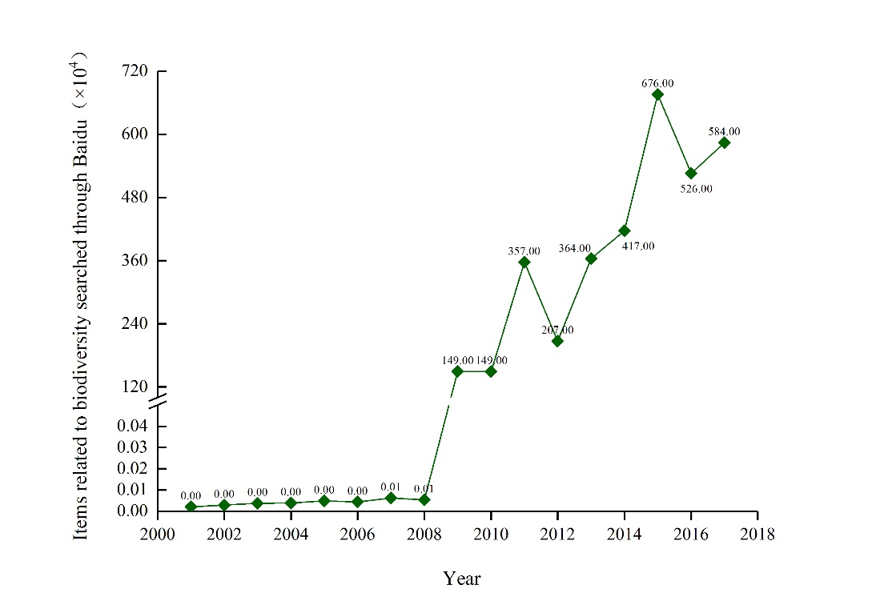
Figure 3.1 Items related to biodiversity searched through Baidu in different years (source: Baidu Search)

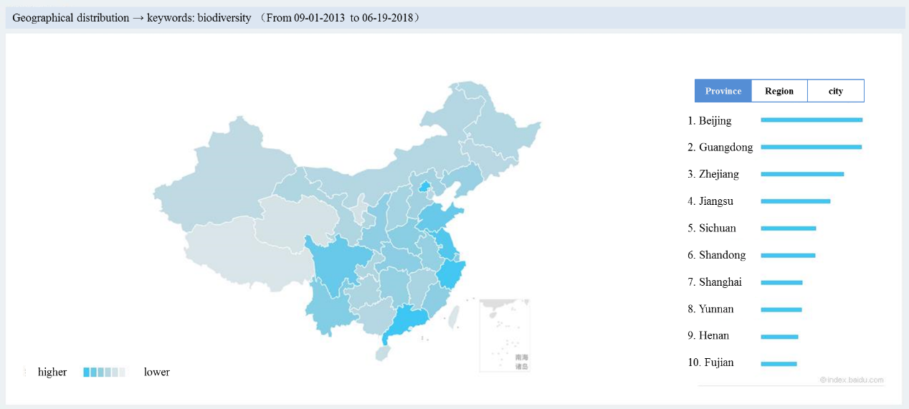
Figure 3.2 Items related to biodiversity searched through Baidu in different provinces (Source: Baidu Search)

- Progress assessment
A math model is used to predict change trends, values and confidence level of assessment indicators by 2020 (Tittensor et al., 2014). However, one end-point reference value cannot be used to assess progress in implementation because most Aichi Biodiversity Targets do not have quantitative values which can be used to assess whether targets in question have been achieved or not. Therefore, China’s progress in achieving Aichi Targets since 2013 is assessed by using different categories of indicators (pressure, state, response or benefit indicators) (Figure 3.3) and comparing the predicted value of indicators in 2020 with the indicator value in 2013 (when the fifth national report was prepared). Levels of progress are categorized as: exceeding target, on track to achieve target, progress towards target but at an insufficient rate, no significant changes, moving away from target and unknown (The same applies to all other Aichi Targets below and will not be repeated). The items related to China’s biodiversity searched through Baidu have substantially increased, so it is predicted that this indicator will take upward trend (Figure 3.3), indicating that China is “on track to achieve this target”.
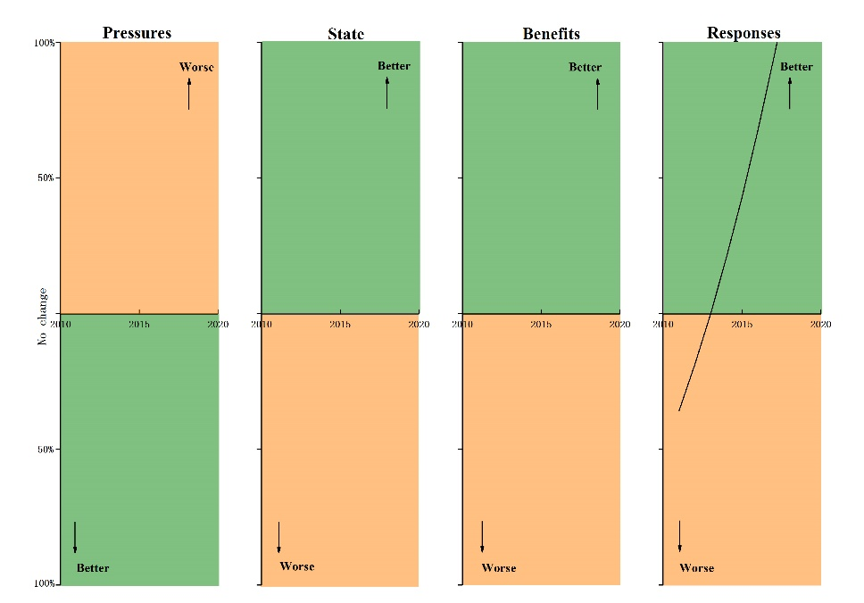
Figure 3.3 Changing trends of indicators related to Aichi Target 1

