Guidelines and template for the review of the draft monitoring framework for the post-2020 global biodiversity framework

Background

- The second meeting of the Open-ended Working Group on the Post-2020 Global Biodiversity Framework invited the Subsidiary Body on Scientific, Technical and Technological Advice at its twenty-fourth meeting to, among other things, carry out a scientific and technical review of the updated goals and targets, and related indicators and baselines, of the draft global biodiversity framework. Under agenda item 3 the Subsidiary Body will consider this issue.
- Tables 1 and 2, presents a draft monitoring framework for the 2050 Goals and the 2030 targets respectively. These tables are being made available for the purposes of peer review. In both tables’ interim formulations of the proposed 2050 goals and milestones and the 2030 targets are provided for context. Review comments are not being sought on these parts of the post-2020 global biodiversity framework at this time. Column A of the tables provides draft components of the goals and targets. Columns B and C of the tables provide draft monitoring elements and indicators to be used at the global level to monitor progress in the implementation of the post-2020 global biodiversity framework. Further column D provides information on the period baseline data is available for the indicator and on the frequency that the indicator is updated where known. Review comments are being sought on columns A, B, C and D only.

II. Submitting Comments

- To ensure that your comments are given due consideration, please send them by e-mail to secretariat@cbd.int, at your earliest convenience but no later than 25 July 2020

- When submitting comments, please adhere to the following guidelines as much as possible:

  - Please provide all comments in writing and in an MS Word or similar document format using the table provided below.

  - Please provide full contact information for the individual/Government/organization submitting the comments.

  - Please avoid commenting on issues related to grammar, spelling, or punctuation, unless it affects the overall meaning of the text, as the document will be edited as the final draft is prepared.

  - To facilitate the revision process please be as specific as possible in your comments. In areas where you feel additional or alternative text or information is required, please suggest, if possible, what this text may look like or what should be included.

  - If you refer to additional sources of information, please include these with your comments when possible or provide a complete reference or hyperlink.

  - Please focus your comments on columns A (components the draft goals and targets), B (monitoring elements), C (indicators) and D (indicator baseline year and frequency of updates) of tables 1 and 2.

  - If you are suggestion the inclusion of additional indicators please provide information on if the indicator is currently operational, the organization supporting its development, its baseline (i.e. the year data is first available) and how frequently the indicator is updated (i.e. monthly, yearly, every two years etc.).

  - All review comments will be posted on the webpage for the post-2020 global biodiversity framework in the interests of transparency

- Should you have any questions regarding the review process, please contact secretariat@cbd.int.

III. Template for Comments

- Please use the review template below when providing comments.

- The complete draft of the monitoring framework has been released in a portable document format (PDF). For tables 1, 2 and 3 column letters and row numbers have been provided as well as page numbers. Please use these as a reference as illustrated in the table below. General comments can be included in the table by referring to Page 0 and Line 0.

TEMPLATE FOR COMMENTS

Review comments on the draft monitoring framework for the post-2020 global biodiversity framework
Contact information
Surname: |  |  |  | Gemmill-Herren
Given Name: |  |  |  | Barbara
Government (if applicable):
Organization: |  |  |  | World Agroforestry Centre and Prescott College
Address: |  |  |  | 23057 State Hwy 16
City: |  |  |  | Capay
Country: |  |  |  | California
E-mail: |  |  |  | Bg11@mac.com
General Comments
This is an example of a general comment
Specific Comments
Table | Page | Column letter | Row number |  | Comment
1 | 2 | C | 16 |  | No indicators are as yet proposed, but I suggest  - Agrobiodiversity Index (Bioversity International. 2018. The Agrobiodiversity Index: Methodology Report v.1.0. Bioversity International, Rome, Italy )- with many indicators described within including data sources  - Simple crop and/or livestock biodiversity measures, such as the Simpson Index- would not be difficult to go back in time and establish a baseline.  - FAO’s TAPE- with a far broader recognition of sustainability (http://www.fao.org/agroecology/tools-tape/en/)
1 | 4 | C | 36 |  | Consider to use  - Measure of wild pollinator visitation to crops, as described in Vaissière, B., Frietas, B., Gemmill-Herren, B. 2011. Protocol to detect and assess pollination deficits in crops: a handbook for its use. FAO, Rome.  - And measure of natural enemy abundance, soil biodiversity indices
1 | 4 | C | 48 |  | No indicators as yet proposed, but I suggest application of the TEEB (The Economics of Ecosystems and Biodiversity assessment framework) AgFood Framework (http://teebweb.org/agrifood/home/evaluation-framework/) . The wording of this goal is unfortunate as there is no one area of greater importance than another for conservation of ecosystem services- but the TEEB framework does assess how a system or area contributes to stocks and flows of ecosystem services (or natural capital)
1 | 5 | C | 54 |  | The Red List Index of pollinating species is proposed; but this is not a good indicator. In large part only pollinating birds and mammals have been recorded on Red Lists, but these are not key pollinators and have not been shown to reflect trends in pollinator populations critical to the survival of ecosystems -manmade or natural. There exists only a Red List of European bees, and few bees, out of the estimated 20,000 have ever been assessed for their status. Regan, E. C., Santini, L., Ingwall‐King, L., Hoffmann, M., Rondinini, C., Symes, A., ... & Butchart, S. H. (2015). Global trends in the status of bird and mammal pollinators. Conservation Letters, 8(6), 397-403.  Although we do not have a distant baseline, a measure that would make more sense would be a simple measure of pollinator visitation to crops, as described in Vaissière, B., Frietas, B., Gemmill-Herren, B. 2011. Protocol to detect and assess pollination deficits in crops: a handbook for its use. FAO, Rome.
1 | 6 | C | 65 |  | - No indicator specified, but I would suggest that use if made of relevant indicators in the Agrobiodiversity Index (Bioversity International. 2018. The Agrobiodiversity Index: Methodology Report v.1.0. Bioversity International, Rome, Italy)
2 | 15 | C | 82, 85 |  | Comment: pollution from nitrogen is not limited to OECD countries (though they are credible with data from OECD countries, but I wonder you will address global trendsn with those in many non-OECD countries being critical )– this graphic is from our TEEB Scientific and Economic Foundations chapter (Pengue, W., Gemmill-Herren, B., Balázs, B., Ortega, E., Viglizzo, E., Acevedo, F., Diaz, D.N., Díaz de Astarloa, D., Fernandez, R., Garibaldi, L.A., Giampetro, M., Goldberg, A., Khosla, A. and Westhoek, H.(2018).‘Eco-agri-foodsystems’: today’s realities and tomorrow’s challenges. In TEEB for Agriculture & Food: Scientific and Economic Foundations. Geneva: UN Environment).  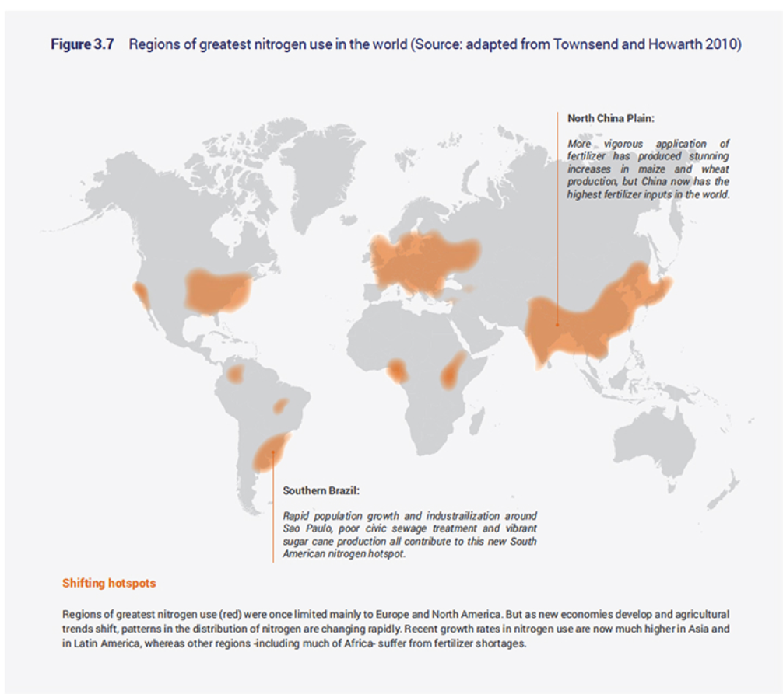
2 | 16 | C | 98 |  | - As per the HLPE agroecology report, and several other new publications climate-smart/sustainable intensification uptake should not be considered the same as and should be disaggregated from agroecological adaptations. These include:  HLPE. (2019). Agroecological and other innovative approaches for sustainable agriculture and food systems that enhance food security and nutrition. A report by the High Level Panel of Experts on Food Security and Nutrition of the Committee on World Food Security, Rome. http://www.fao.org/3/ca5602en/ca5602en.pdf  Sinclair, F., Wezel, A., Mbow, C., Chomba, S., Robiglio, V., and Harrison, R. 2019. “The Contribution of Agroecological Approaches to Realizing Climate-Resilient Agriculture.” Rotterdam and Washington, DC. https://cdn.gca.org/assets/2019-12/TheContributionsOfAgroecologicalApproaches.pdf  Andrieu N, Kebede Y. 2020. Climate Change and Agroecology and case study of CCAFS. CCAFS Working Paper no. 313. Wageningen, the Netherlands: CGIAR Research Program on Climate Change, Agriculture and Food Security (CCAFS).  Thus for the indicators here, I highly recommend making use of either or both of  - Ten elements of agroecology (FAO, 2018) which include: [diversity, co-creation of knowledge, synergies, efficiency, recycling, resilience, human and social value, culture and food traditions, responsible governance, circular and solidarity economy]  - Additional criteria to measure progress towards achieving transformative agroecology, based on Gliessman’s hierarchy for agroecological transition include: [Level 1: Increasing efficiency to reduce use and consumption of environmentally damaging inputs; Level 2: substitute alternative practices for industrial/conventional inputs and practices; Level 3: Redesign the agroecosystem to that it functions on the basis of a new set of ecological processes; Level 4: Re-establish a more direct connection between those who grow our food and those who consume it; Level 5: On these foundations, build a new global food system, based on equity, participation, democracy, and justice, that is not only sustainable but helps restore and protects earth’s life support systems upon which we all depend.]  We can work with you to convert these into viable indicators.  Two possible wordings:  o % land under agricultural production utilizing pesticide-free, soil conserving, C-sequestering practices or “Proportion of agricultural land under practices that conserve and sustainably use biodiversity, soil biology and favour the provision of ecosystem services (for example agroforestry, organic farming, and agroecology)
2 |  | A | 117 |  | I find this wording very unfortunate, ending with reducing productivity gaps by at least 50%- as if that is the sole metric. If biodiversity is to be mainstreamed into agriculture and vice versa we need to recognize the many benefits that the two can generate together, and productivity is not the sole metric.
2 | 20 | C | 118 |  | Suggest rewording:  Proportion of agricultural land under practices that conserve and sustainably use biodiversity, soil biology and favour the provision of ecosystem services (for example agroforestry, organic farming, and agroecology)
2 | 20 | C | 121 |  | I commented on this with respect to goals, and this is equally relevant here:  The Red List Index of pollinating species is proposed; but this is not a good indicator. In large part only pollinating birds and mammals have been recorded on Red Lists, but these are not key pollinators and have not been shown to reflect trends in pollinator populations critical to the survival of ecosystems -manmade or natural. There exists only a Red List of European bees, and few bees, out of the estimated 20,000 have ever been assessed for their status. Regan, E. C., Santini, L., Ingwall‐King, L., Hoffmann, M., Rondinini, C., Symes, A., ... & Butchart, S. H. (2015). Global trends in the status of bird and mammal pollinators. Conservation Letters, 8(6), 397-403.  Although we do not have a distant baseline, a measure that would make more sense would be a simple measure of pollinator visitation to crops, as described in Vaissière, B., Frietas, B., Gemmill-Herren, B. 2011. Protocol to detect and assess pollination deficits in crops: a handbook for its use. FAO, Rome.
2 | 21 | B | 129 |  | To ensure that the monitoring elements and indicators align with the target, it is not sufficient to monitor trends in natural freshwater ecosystems proving (surely you mean providing?) good ambient water- one should monitor:  - trends in land management systems that contribute to “good” ambient water, or  - reductions in loads of agricultural chemicals.
2 | 22 | C | 133 |  | - a pollination indicator could be used, or total weight of insects as per this publication, but not in natural areas, in working landscapes:  Hallmann CA, Sorg M, Jongejans E, Siepel H, Hofland N, Schwan H, et al. (2017) More than 75 percent decline over 27 years in total flying insect biomass in protected areas. PLoS ONE 12(10): e0185809. https://doi.org/10.1371/journal.pone.0185809  Methodology described in S2 of the above publication
2 | 25-26 | C | 152, 153, 154, 155 |  | This biodiversity mainstreaming target is an important one. FAO adopted a biodiversity mainstreaming strategy in December 2019 which has a detailed articulation of biodiversity and agriculture linkages- the plan of implementation for that should align with the Post2020 Framework.  For effective implementation of biodiversity mainstreaming, it is critical to respect and support inclusive, democratic and participatory processes that build biodiversity mainstreaming policy co-created with local communities and indigenous peoples.  Several people myself included would be available to work with you on specific indicators.
2 | 26 | C | 156 |  | - Trends in policies supporting agricultural production practices that conserve and sustainably use biodiversity and favor ecosystem services, for example agroforestry, organic farming, and agroecology  (FAO is gathering data in this respect)
 |  |  |  |  | Additional rows can be added to this table by selecting “Table” followed by “insert” and “rows below”

Comments should be sent by e-mail to secretariat@cbd.int no later than 25 July 2020.

CBD/WG2020/REC/2/1
https://www.cbd.int/conferences/post2020

